Experiment No. 1
Aim: Implement programs to demonstrate control flow and arrays using Java.
1. Implement a Java program to find the factorial of a given number.
import java.util.Scanner; public class FactorialProgram { public static void main(String[] args) {
Scanner sc = new Scanner(System.in); System.out.print("Enter a number: "); int num = sc.nextInt(); long factorial = 1; if (num < 0) {
System.out.println("Factorial not defined for negative numbers.");
} else { for (int i = 1; i <= num; i++) { factorial = factorial * i;
}
System.out.println("Factorial of " + num + " is: " + factorial);
} sc.close();
}
}
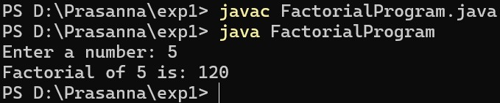

2. Implement a Java program to check whether a given number is prime or not. (Take the number as a command-line argument.)
public class PrimeCheck { public static void main(String[] args) { if (args.length == 0) {
System.out.println("Please provide a number as a command-line argument.");
return;
}
int num = Integer.parseInt(args[0]); boolean isPrime = true; if (num <= 1) { isPrime = false;
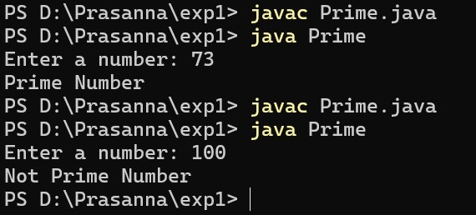
} else { for (int i = 2; i <= Math.sqrt(num); i++) { if (num % i == 0) { isPrime = false; break;
}
} } if (isPrime) {
System.out.println(num + " is a Prime Number.");
} else {
System.out.println(num + " is NOT a Prime Number.");
}
}
}

3. Implement a Java program to sort a given list of 10 numbers in ascending order.

import java.util.Scanner; public class SortTenNumbers { public static void main(String[] args) { Scanner sc = new Scanner(System.in); int[] arr = new int[10];
System.out.println("Enter 10 numbers:"); for (int i = 0; i < 10; i++) { arr[i] = sc.nextInt();
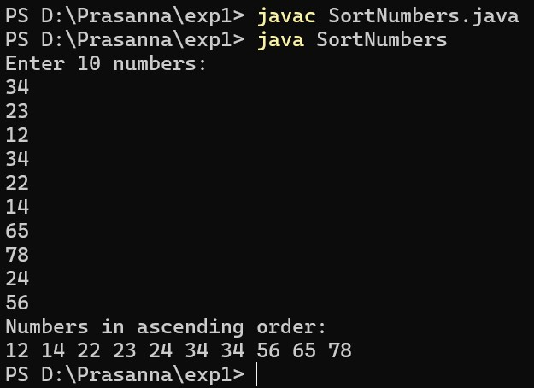
} for (int i = 0; i < arr.length - 1; i++) { for (int j = 0; j < arr.length - 1 - i; j++) { if (arr[j] > arr[j + 1]) { int temp = arr[j]; arr[j] = arr[j + 1]; arr[j + 1] = temp;
}
}
}
System.out.println("Numbers in ascending order:"); for (int num : arr) {
System.out.print(num + " ");
} sc.close();
}
}

4. Implement a Java program to merge two sorted arrays.
import java.util.Scanner; public class MergeSortedArrays { public static void main(String[] args) {
Scanner sc = new Scanner(System.in); System.out.print("Enter size of first array: "); int n1 = sc.nextInt(); int[] a = new int[n1];
System.out.println("Enter elements of first sorted array:"); for (int i = 0; i < n1; i++) { a[i] = sc.nextInt();
}
System.out.print("Enter size of second array: "); int n2 = sc.nextInt(); int[] b = new int[n2];
System.out.println("Enter elements of second sorted array:"); for (int i = 0; i < n2; i++) { b[i] = sc.nextInt();
}
int[] merged = new int[n1 + n2]; int i = 0, j = 0, k = 0;

while (i < n1 && j < n2) { if (a[i] <= b[j]) { merged[k++] = a[i++];
} else { merged[k++] = b[j++]; }
} while (i < n1) { merged[k++] = a[i++];
} while (j < n2) { merged[k++] = b[j++];
}
System.out.println("Merged array:"); for (int num : merged) {
System.out.print(num + " ");
} sc.close();
}
}
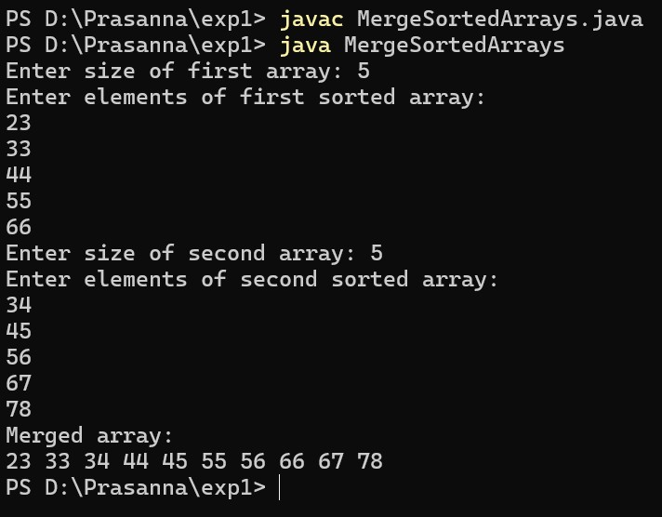

5. Implement a Java program to perform 2×2 matrix multiplication, addition, and transpose (using a switch case).
import java.util.Scanner; public class MatrixOperations { public static void main(String[] args) { Scanner sc = new Scanner(System.in); int[][] A = new int[2][2]; int[][] B = new int[2][2]; int[][] result = new int[2][2];
System.out.println("Enter elements of Matrix A:"); for (int i = 0; i < 2; i++) for (int j = 0; j < 2; j++)
A[i][j] = sc.nextInt();
System.out.println("Enter elements of Matrix B:"); for (int i = 0; i < 2; i++) for (int j = 0; j < 2; j++) B[i][j] = sc.nextInt(); while (true) { for (int i = 0; i < 2; i++) for (int j = 0; j < 2; j++) result[i][j] = 0;
System.out.println("1.Addition 2.Multiplication 3.Transpose 4.Exit"); int choice = sc.nextInt(); switch (choice) { case 1:
for (int i = 0; i < 2; i++) for (int j = 0; j < 2; j++) result[i][j] = A[i][j] + B[i][j]; System.out.println("Result:"); for (int i = 0; i < 2; i++) { for (int j = 0; j < 2; j++)
System.out.print(result[i][j] + " ");
System.out.println();
} break; case 2:
for (int i = 0; i < 2; i++) for (int j = 0; j < 2; j++) for (int k = 0; k < 2; k++) result[i][j] += A[i][k] * B[k][j]; System.out.println("Result:"); for (int i = 0; i < 2; i++) { for (int j = 0; j < 2; j++)
System.out.print(result[i][j] + " ");
System.out.println();
} break; case 3:
System.out.println("Transpose of Matrix A:"); for (int i = 0; i < 2; i++) { for (int j = 0; j < 2; j++)
System.out.print(A[j][i] + " ");
System.out.println();
} break; case 4:
sc.close();
return; default:
System.out.println("Invalid choice");
}
}
}
}
